
Supersaver Prototype Reactions/ Research Report (Round 1 2022)
Dec 2022 | Kelly Peterson Ishaan Kansal Razeen Jivani Meghan DesaiJordan Caines Kevin Fu
Research Brief

| Research Objectives:
- What areas of confusion, friction or frustration exist in the sign up, transfer and check out process?
- How do Cx feel about having to re-enter their information when signing up for DoorDash pharmacy?
- How do Cx feel about the medicine cabinet?
- Are Cx interested in using DoorDash pharmacy after exposure to the prototype?

| Prototype Link
https://www.figma.com/proto/0ypUyuKRlpA8xVeS1g7lWY/SuperSave?node-id=1131%3A200436&scaling=scale-down&page-id=1110%3A200435&starting-point-node-id=1131%3A200436
| Sample:
- 3 out 8 respondents showed up and participated in their scheduled interview session with us, the gap in participation is likely due to the time of year
- Recommend additional testing come Jan
| Summary of results:
- Overall respondents were excited about the idea of supersaver and that it would have some impact on their future order frequency though the level of impact varied significantly by respondent
- All respondents misinterpreted the initial instructions, in different ways, and this copy should be revisited
  - One respondent thought you had to place orders at 3 restaurants to get a promotion
  - One respondent thought that only 3 restaurants offered $0 delivery and you could choose to order from them
  - One respondent thought that you could select 3 restaurants from a preset list of participating restaurants
  - One Cx thought $0 delivery was confusing and that Free delivery would be more clear
- All respondents wanted to click on the box next to the preselected Shake shack to add a restaurant to their supersave (once they understood what supersave was)
  - They did not realize they could click on the icon on each store page
    - One Cx wanted to click on the teal $0 delivery text at the bottom of the screen
    - Once the logo was brought to their attention they noticed it everywhere
    - Some Cx noticed the difference between a filled in teal logo and a teal outline logo once they understood about the logo
    - They did not notice the blue boxes in between carousels explaining where to click
- All Cx were skeptical about the time frame in which this would be available and assumed it was a limited time deal
- Cx felt everything beyond the homepage was clear

| Recommendations:
- Update copy in the initial screen to make it clear that “you” pick “any 3 restaurants to add
- Add copy explaining to “click on the logo” to add a supersave
- Make it clear that the restaurant that was picked can be changed
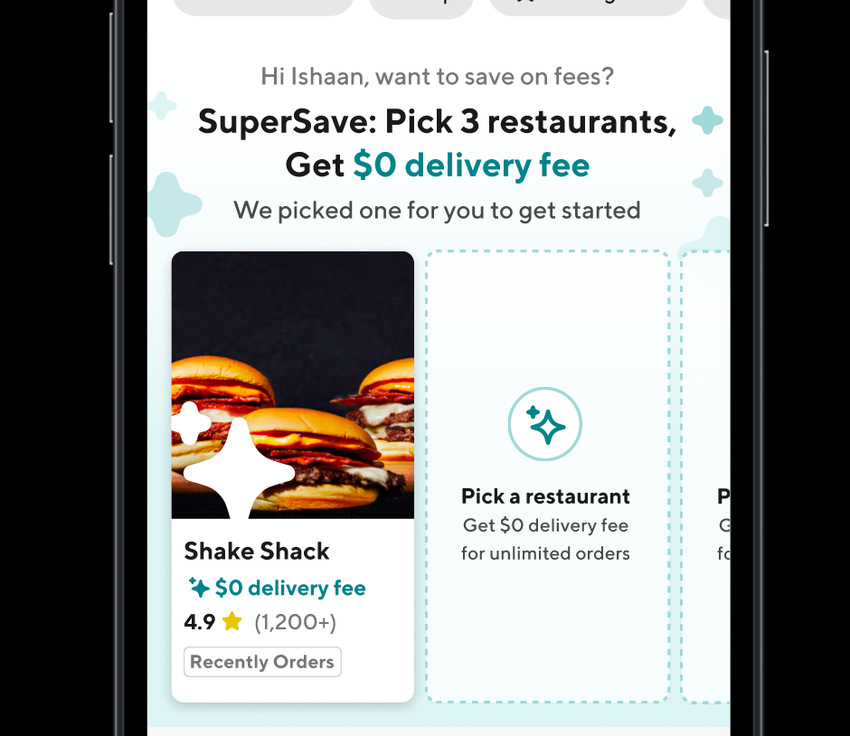
- Move blue box explaining where to click to add a Rx above the first carousel to increase visibility, then include below
- If possible make the $0 delivery fee sign clickable for a period of time
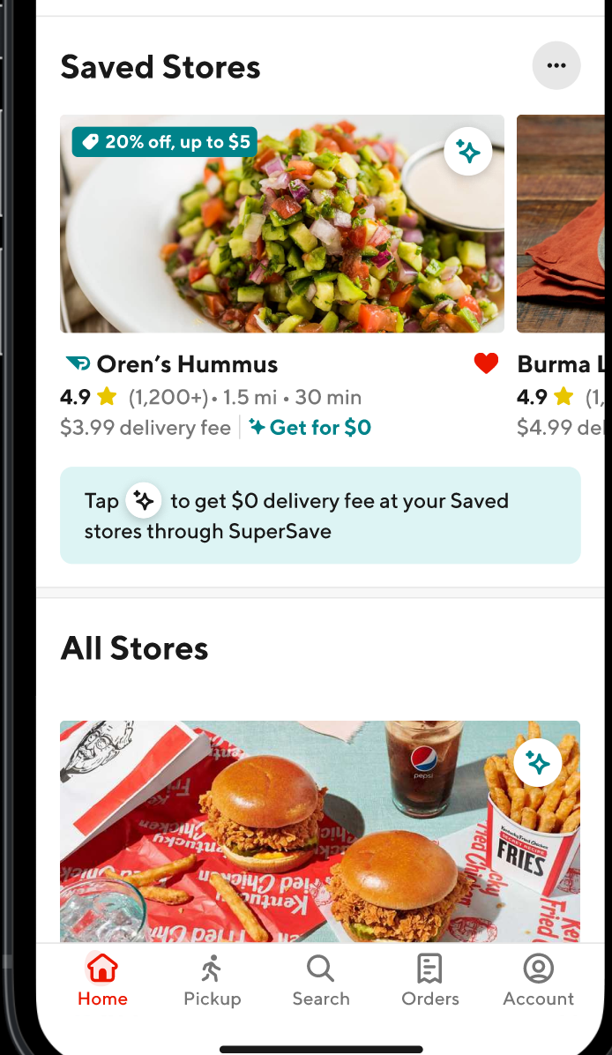
- Adjust text in teal box to make it clear that they need to tap the logo to get $0 delivery fee at this store
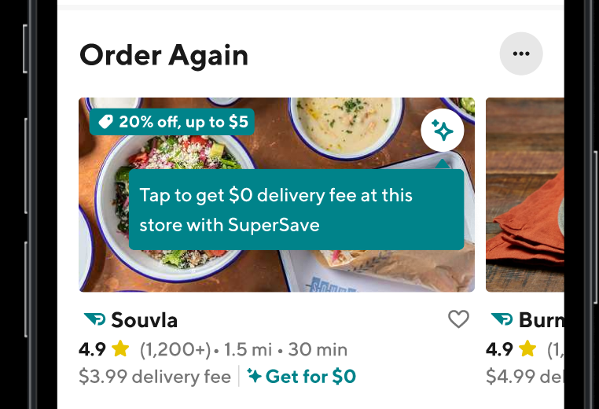

| Link to recordings:

Recording Link | PW
https://doordash.zoom.us/rec/share/ZR07Fud4YVTkTcAKKLZWa8KPb701-VeqaF6a0Rxz623VxHhNaL5xXFdrZ_qDEw9_.3vauRC0fIlx_n5CT | NmRO@=9z
https://doordash.zoom.us/rec/share/gS-ydnFsfMQ9eIDm3TzjL-1RkmbaqEGYSF1M1NuueW0tJIvh9j59NFFTmRgd0Xpq.Gz7jtOZjEwM2ZYIz | u$9JdoSC
https://doordash.zoom.us/rec/share/QVF04UnlH6uQR90zOlZrZq0jQFC1cpGTkosCEoDG9zm5PFBFgWrKRKUDV1dl8DQ.VoyQS6b3xlZGHh5a | R3B*C8?+

